RESUME
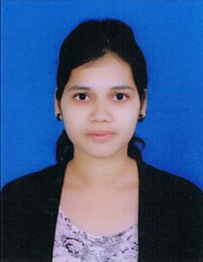
Ekagrata Panigrahy
B.TECH (civil engineering)
GIET, GUNUPUR
RAYAGADA, ODISHA
Email-id:- ekapanigrahy@gmail.com
Mobile: - 8280135778

Career objective:-

I want to succeed in a stimulating and challenging environment, excelling it by hard work, perseverance and dedication.

Education qualifications:-

Qualification | Board/university | School/college | Year of passing | Percentage/ SGPA
B.tech | BPUT | GIET, Gunupur | 2016 | 8.18(up to 7th sem)
Intermediate (10+2) | CHSE | SVM, Neelkanth nagar | 2012 | 60.5%
Matric(10th) | HSCE | SSVM, Ramahari nagar | 2010 | 86%

Skill:-

- STAAD PRO completed from Central Tool room and Training Centre(CTTC),Bhubaneswar.
- AUTOCAD completed.

Workshop Attended :-
- C++ Conference attended.

Extra curricular activities:
- Dancing,rifle shooting,playing khokho .

Technical Experience
Projects:

Town planning with waste management :waste water purification, septic tank.

Personality Traits:-
- Smart worker
- Adoptable, adventurous, fun loving
Strength:-
I am confident, passionate, perfectionist, committed and hard working. I believe in team work and I am a quick learner.
Personal details:-
- Father’s name:- Ramesh Chandra Panigrahy
- Permanent address:- ram nagar 4th lane,lanjipalli,Berhampur,ganjam ,Orrisa
- Date of birth:- 10th jan1995
- Gender : - Female
- Marital status:- Single
- Languages known:- English, Hindi, Oriya
- Nationality:- Indian
Declaration:-
I affirm that the above information is true to the best of my knowledge.

Date:- 30.06.2015 Ekagrata Panigrahy
Place:- Gunupur Signature

